# Abstract

The aim of the project was to generate a simple 3D model of a human being for 3D printing. This project explores the methods behind mesh handling and how to effectively print a 3D model. The test was done by Kuan Wen Xuan utilizing a iPhone 14 back camera on the PolyCam application. Mesh fixing and conversion was done with fusion 360 and an online platform 3dviewer.net was utilized. The final model was printed in silky green PLA on a Creality Ender 3v2 3D printer. The slicer used was CURA. Due to the unoptimized setting, stringing can be observed and hence requires post processing before improvement can be made.

# Objective

* Create a 3D model of a human with at least 80% similarity
* Print out mesh on a 3D printer with Fused Deposition Modeling technology
* Document the process and share the results.

# PolyCam

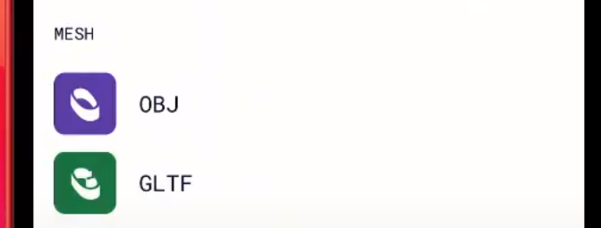

* Files are scanned and imported from PolyCam
* Original File format is. GLTF due to non-premium user format

# https://3dviewer.net/

**Using a free online 3dviewer at 3dviewer.net, it is observed the apparent scanned 3d model has some defects due to the picture provided being unable to capture covered areas. In order to mitigate the errors, the mesh is transported to fusion 360 where it is repaired and converted to an STL file.**

**STL File Format**

While choosing the format of the encoding used when exporting the STL file there were 2 choices to deliberate upon. Based on online research,

“

* **Binary** - Uses binary encoding for the STL file. Binary files are generally smaller and better for 3d printing than ASCII files.
* **ASCII** - Uses ASCII encoding for the STL files. ASCII files are generally larger than binary files, but easier to manually inspect and debug.

**“**

## Ultimaker CURA

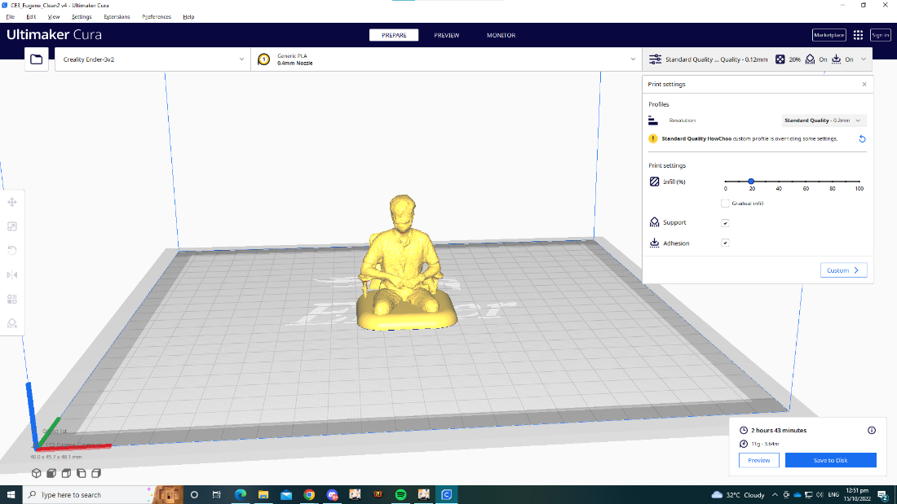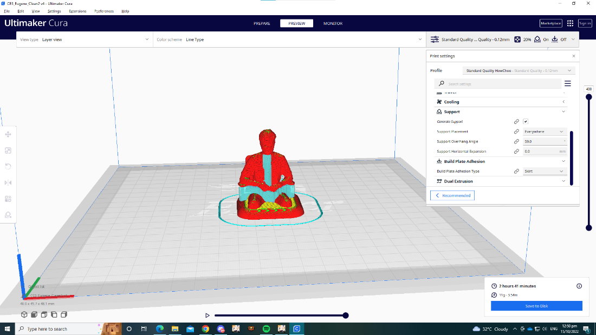For slicing of the STL file type, Ultimaker cura was used due to it being open-source and compaitable with multiple different 3d Printers. The figures showcase the sliced interface. For this print the layer height was set at 0.12 mm and the print took roughtly 3 hours in total.

Figure 1 Scanned STL Model Edited

Figure 2 Scanned STL Model Edited Print Preview with supports

# Final Results of 3D printing